PRESS ANNOUNCEMENT



DAYLIGHT ANNOUNCES PUBLICATION OF

VINCENT CIANNI: GAYS IN THE MILITARY
INTERVIEWS AND PHOTOGRAPHS BY VINCENT CIANNI

WITH ESSAYS BY ALISON NORDSTRÖM, LT DONALD R. BRAMER,
AND ALAN M. STEINMAN, MD

MAY 2014
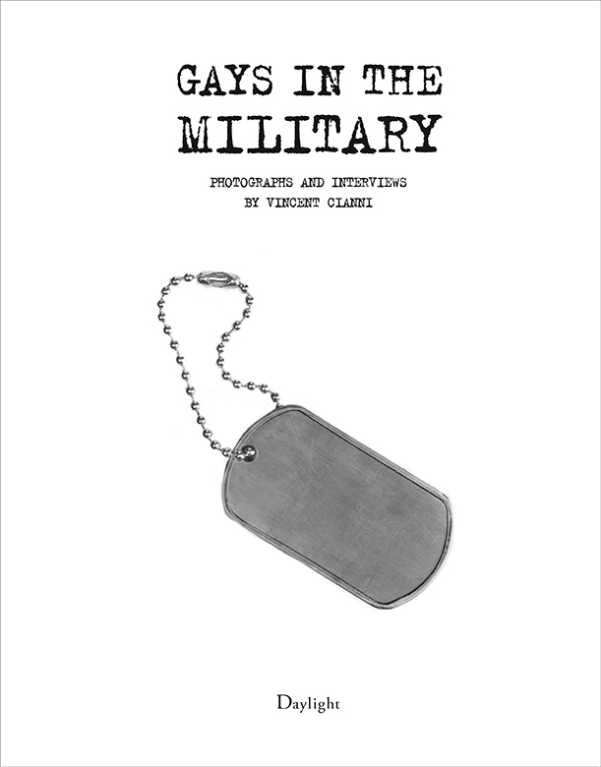

VINCENT CIANNI IN CONVERSATION WITH ALISON NORDSTRÖM
AT THE CAMERA CLUB OF NEW YORK
TUESDAY, APRIL 8, 7PM

“Vincent Cianni’s photographic essay on gays in the military contributes to the recognition that real people with valuable skills and experience -- indistinguishable from their straight counerterparts and not some stereotype gay bogeyman -- compose those serving on active duty and in the reserves. This book will thus take its place among the documentary evidence of a signficiant milestone in our nation’s military history; equality for gays and lesbians in the nation’s armed forces.”—Alan M. Steinman, MD

As the Human Rights Commission attests, the U.S. military has a long history of human rights abuses against homosexuals resulting in lost careers of servicemen and women many of whom are highly skilled, well educated, patriotic, courageous, and productive. From November 2009 to June 2013,
Vincent Cianni (born 1952), a documentary photographer whose work explores community, memory, and the human condition, made a series of road trips across the United States to interview and photograph approximately 100 gay and lesbian U.S. military veterans and active-duty service members. His mission was to document how the military’s ban on openly gay and lesbian service personnel, which ended just two and a half years ago, impacted on their careers in the armed forces and in their personal lives afterwards.

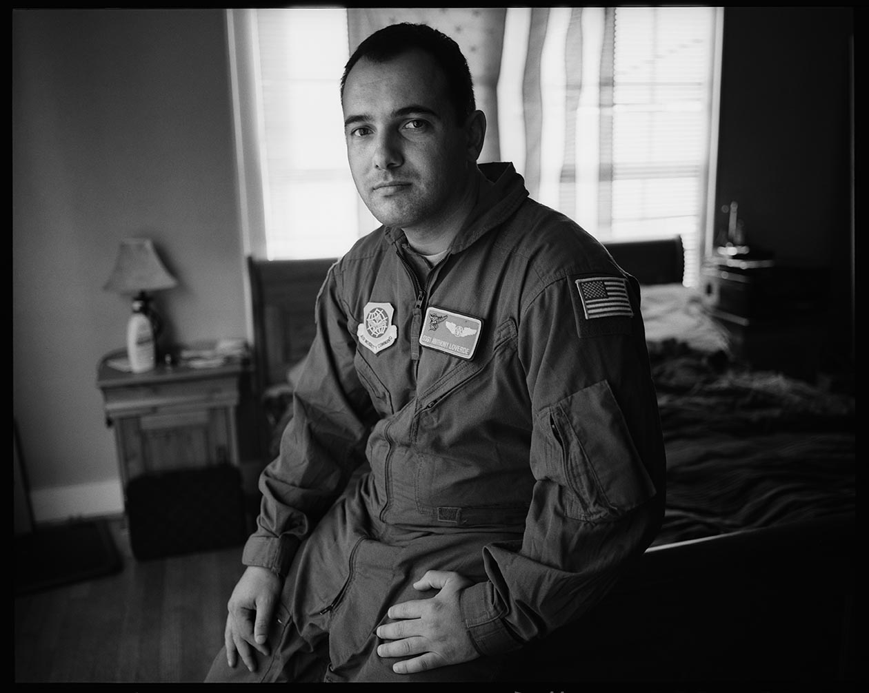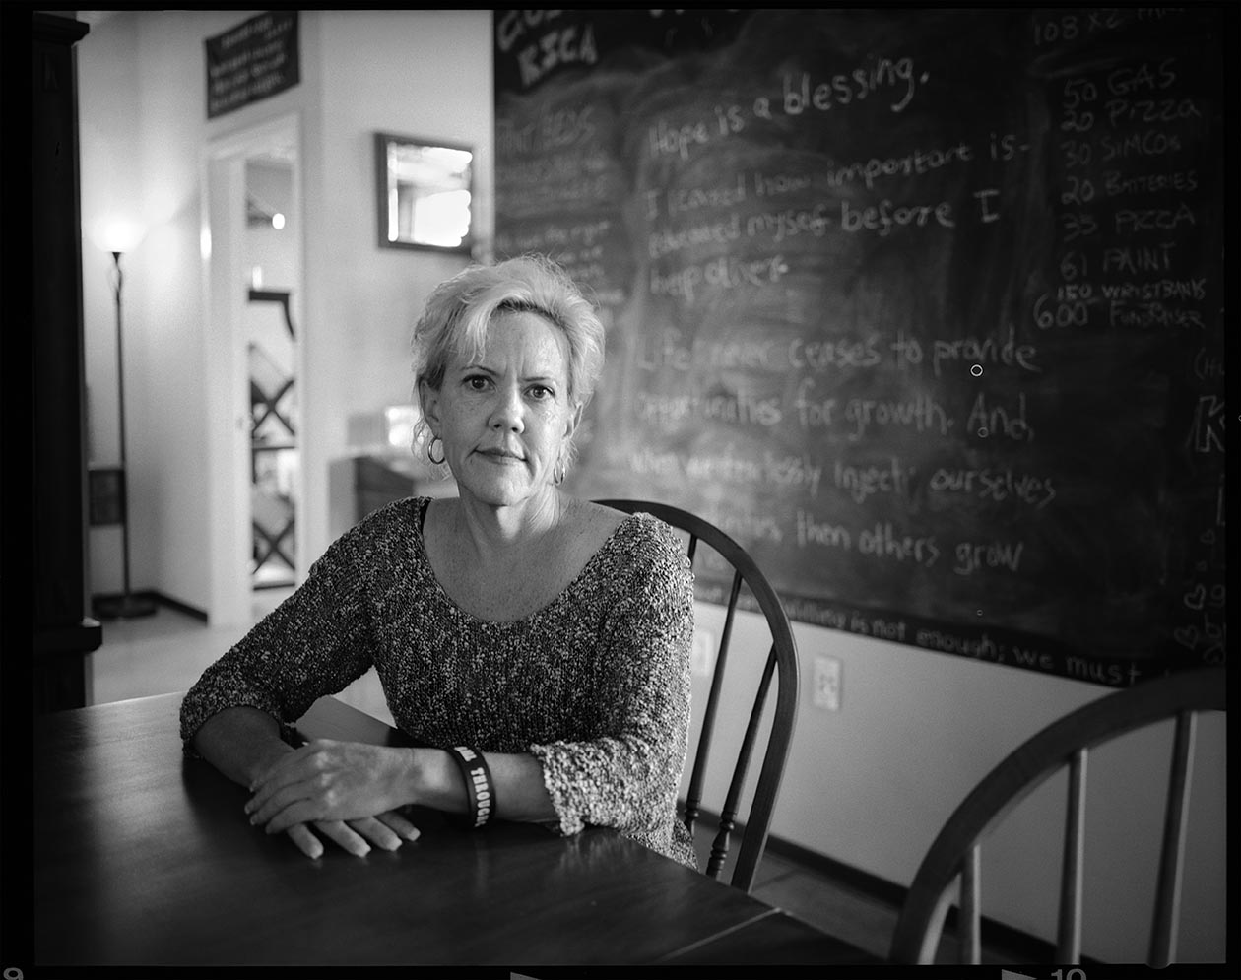
L-R: Anthony Loverde, Little Rock, AR. 2012. Staff Sergeant, U.S. Air Force, 2001-Present. Loadmaster. Active duty, honorable discharge, homosexual conduct; deployed Iraq and Afghanistan 2012 at previous rank; continued career as if uninterrupted. Debra Fowler, Lowell, Mass. Specialist, U.S. Army, 1986-88. Korean Linguist. Dishonorable Discharge, fraudulent entry, outed when being investigated for security clearance.

The culmination of Cianni’s intense three-year journey is Gays in the Military (Daylight Books,
May 2014) which brings together over fifty intimate portraits and testimonies of individuals and couples who openly share their compelling, moving, sometimes harrowing stories of the harassment, discrimination and indignities they endured as gay and lesbian veterans and service members. Many interviews took place while the ban was still in place that is a testament to the trust that Cianni established with them.

The age range of the servicemen and women in Gays in the Military spans sixty years. They served in World War II, Vietnam, the Gulf War, Iraq, Afghanistan, Kuwait, stateside, and in the reserves. Many attained high rank, received numerous medals, and held top-level jobs. The civil rights violations they endured oftentimes prohibited them from receiving the benefits accorded them for serving in the military. The stigma associated with such frequent punishments as dishonorable discharge was worse when a man or women returned to civilian life unable to find a job that matched his or her skills. These gay men and women spent their entire military careers living under the threat of being “outed” and discharged. In order to hide and live a lie, many repressed their emotions and denied themselves basic human intimacies.

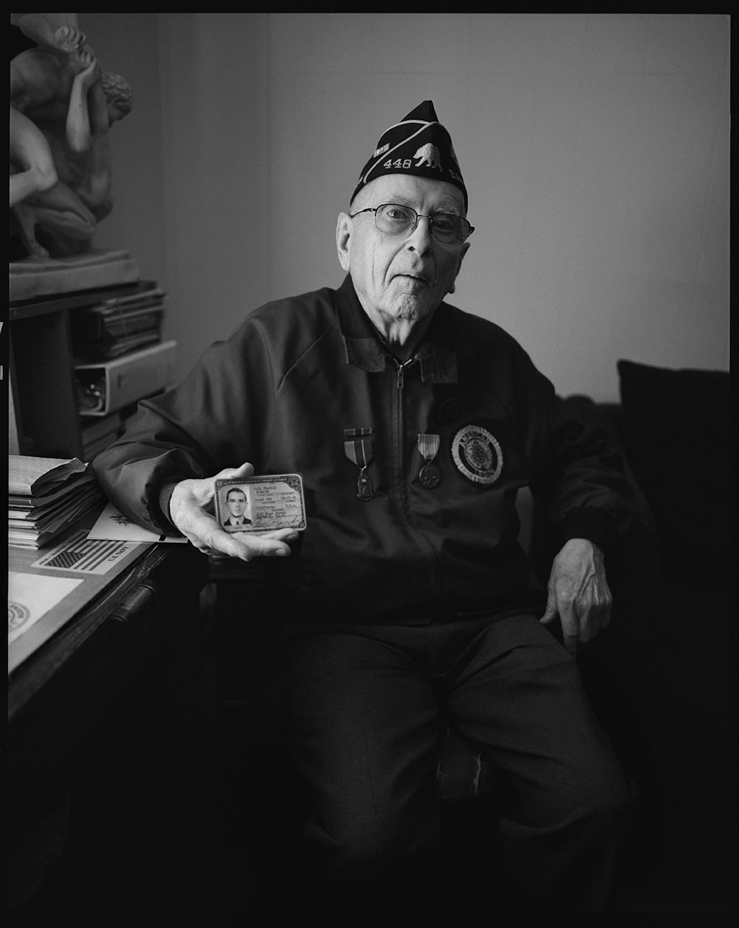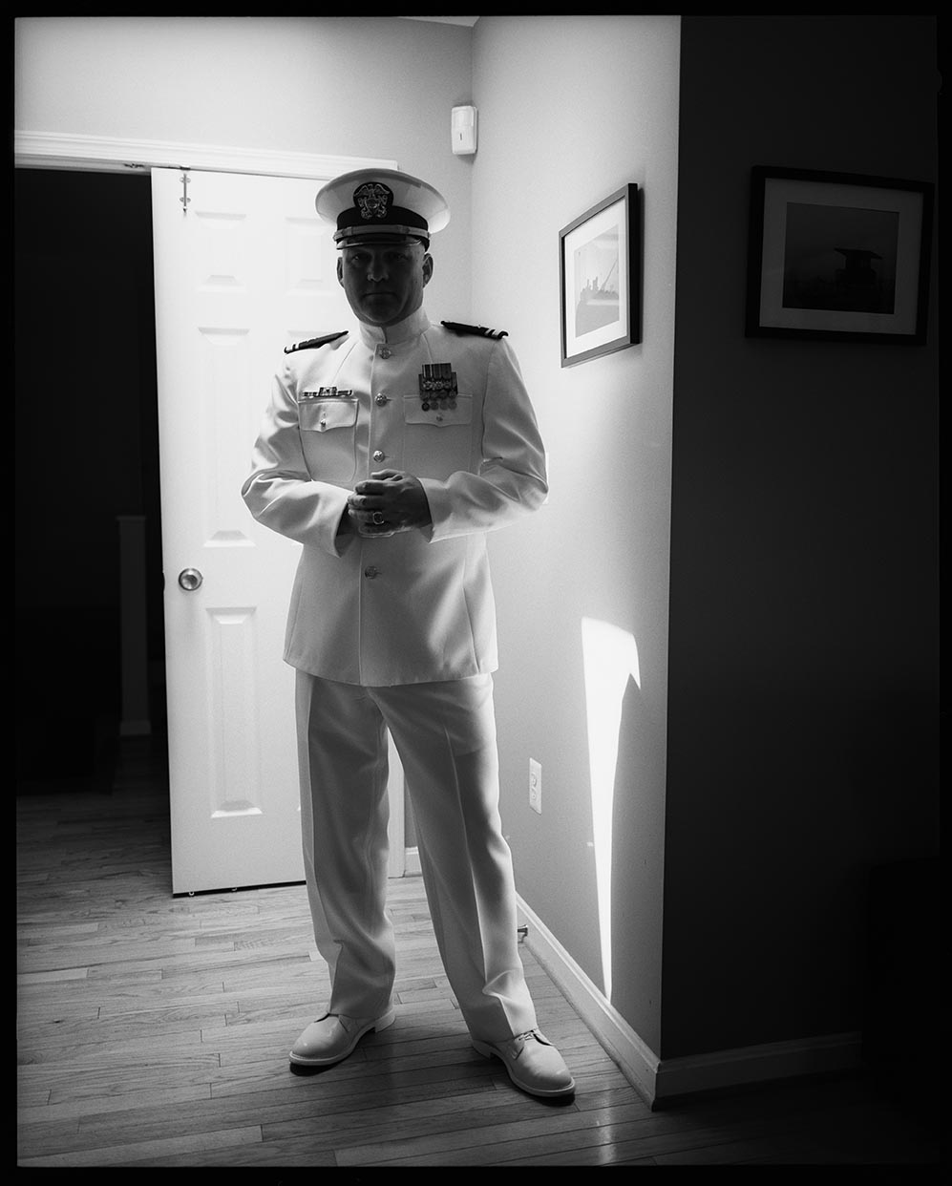
L-R Paul Goercke, San Francisco. Messman/Staff Officer, U.S. Merchant Marines, 1944-45. Deployed in Ie Shima Island, Japan; Hawaii and Saipan. Donald R. Bramer, Washington, D.C. Lieutenant (O-3), U.S. Navy, 2002-present. Intellience Officer. Top Secret Security Clearance; multiple deployments to the Middle East; provided anonymous testimony during the hearings to repeal ‘don’t ask, don’t tell.’

The book presents three insightful essays that shed light on the cultural, personal and political consequences of the ban on homosexuality.

Dr. Alison Nordström is Senior Curator of Photographs at George Eastman House. She writes about Cianni’s powerful portraits and the role of photography as an “exercise in witnessing and truth telling.” She places his work in the tradition of the documentary photography of Lewis Hine and Walker Evans.

Alan M. Steinman, MD was a Rear Admiral, U.S. Public Health Service and U.S. Guard from 1972 to 1997. Retired, he came out publicly in 2003 on the tenth anniversary of “Don’t Ask, Don’t Tell.” He remained “in the closet” the entire time he was in service. He writes about the history of the laws and policies banning gays and lesbians from serving in the military, describing them as “deliberately draconian.”

Lt. Donald R. Bramer (see caption above) writes about the challenges of living under the “Don’t Ask, Don’t Tell” policy which lasted from 1993 to 2011 and maintaining a relationship with his partner, who was also in the service, with the long separations and the emotional toll of carrying the “burden of silence and invisibility each day that we served. We fought harder and trained harder just to wear the uniform with the same distinction as those around us.”

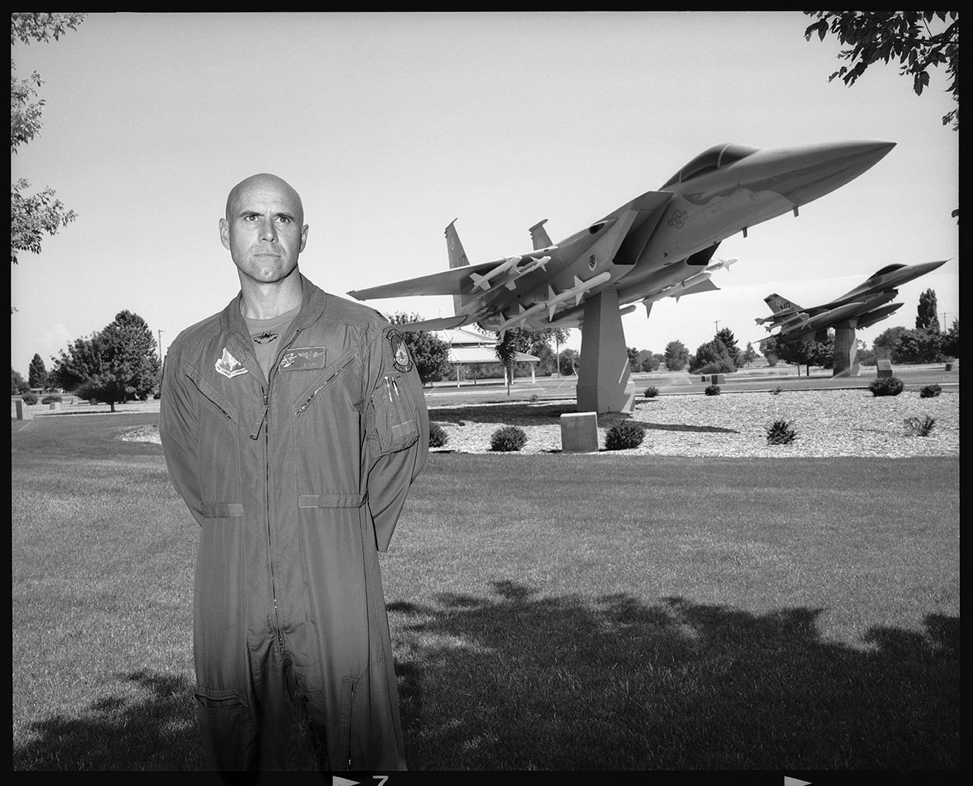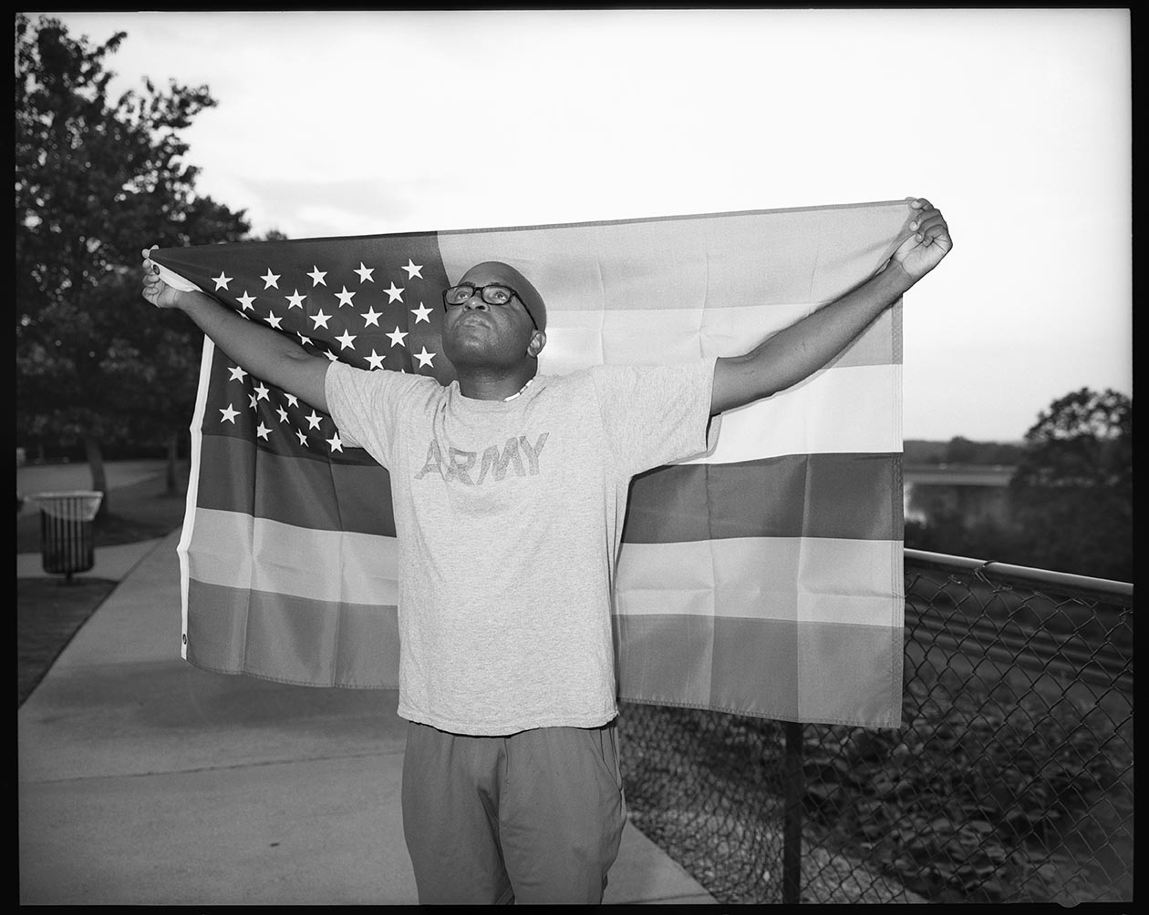

L-R Victor Fehrenbach, Boise, Idaho. Lieutenant Colonel, U.S. Air Force, 1991-2011. Retired. F-15E Fighter Pilot. Tours of duty in Iraq, Kuwait and Afghanistan; successfully fought his discharge under ‘don’t ask, don’t tell,’ after coming out on television in 2009. Travis Jackson, Montgomery, AL, 2011. Sergeant, U.S. Army 2004-2009. Chaplain’s Assistant. Deployed to Iraq 2007-2008, general discharge (under honorable conditions); patterns of misconduct.

Vincent Cianni is a documentary photographer whose work explores community, memory, and the human condition through image, text and audio. Cianni holds an MFA in Photography from the SUNY New Paltz and teaches photography at Parsons, the New School for Design and the International Center of Photography. The David M. Rubenstein Rare Book and Manuscript Library (Archive of Documentary Arts), Duke University established a study archive to insure the preservation of all his documentary projects, including negatives, contacts and correspondence. We Skate Hardcore, an eight-year documentary project of inline skaters in Williamsburg, Brooklyn published by NYU Press and the Center for Documentary Studies in 2004, was awarded the American Association of University Press Best Book Design. A major survey of this work was exhibited at the Museum of the City of New York in 2006. His photographs have been exhibited and collected nationally, including the Los Angeles County Museum of Art, Museum of Fine Arts, Houston, and the George Eastman House, as well as in London, France, and Germany, and published in The New York Times, Double Take, Aperture, The New Yorker, Photography as Activism; New York 400: A Visual History of America’s Greatest City; and The Polaroid Book. To visit the artist's website, go here.

Related Event:

Vincent Cianni: A Conversation about his new book Gays in the Military
With Alison Nordstrom followed by a Q & A
Tuesday, April 8, 2014, 7PM
The Camera Club of New York
The Arts Building 336 West 37th Street
Suite 206
New York, NY 10018-4212
For information call us at 212-260-9927.
Or email us at:info@cameraclubny.org

Free admission.

Seating is very limited.

Daylight is a non-profit organization dedicated to publishing art and photography books. By exploring the documentary mode along with the more conceptual concerns of fine art, Daylight's uniquely collectible publications work to revitalize the relationship between art, photography, and the world-at-large. For information, visit www.daylightbooks.org. To check out Daylight Digital, visit www.daylightdigital.co.

Daylight media contact: Andrea Smith; andreasmith202@gmail.com; 646-220-5950.

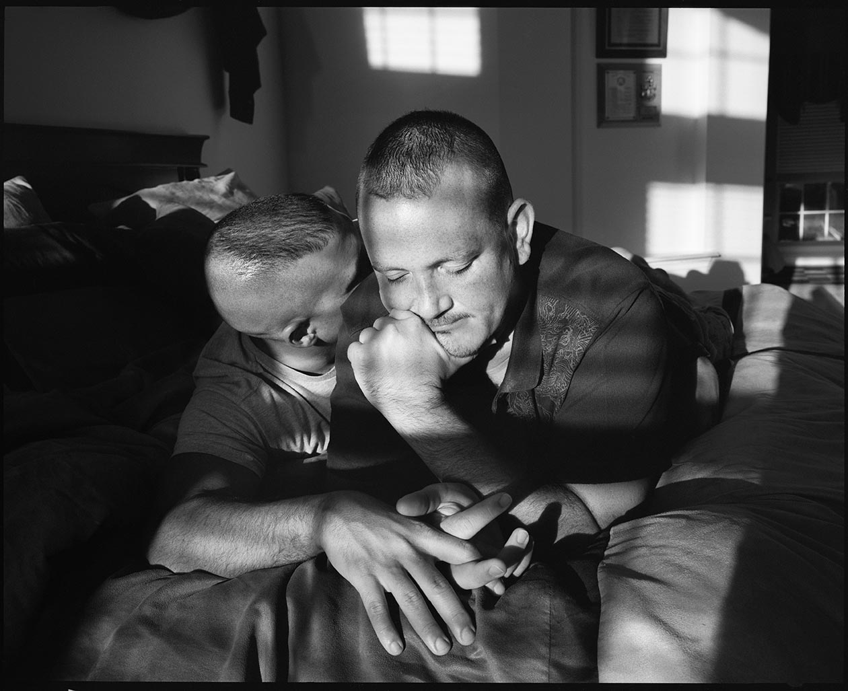
Heather Davies, left, Round Rock, Tex. with her former partner Shane Walley. Lieutenant, U.S. Navy, 1989-98. Operations Watch Officer and Officer Recruiter. Resigned commission. Matt McCary, right, Orange Park, Fla. Airman First Class E-3, U.S. Air Force, 1998-2000. Intelligence Specialist. Honorable Discharge; put under arrest after being singled out by co-worker; discharged within five days with no investigation. David Cochenic, Orange Park, Fla. Chief Petty Officer E-7, U.S. Navy, 1992-present. Field Medical Service Technician, Aerospace Medical Technician.

